## WatchIO

WatchIO is the uniform language protocol of the Unimacs bridge. NavVision can talk with the Unimacs bridge using the WatchIO protocol.

This connection results in the following:

* Unimacs (sensor) data can be shown in NavVision and, if necessary, it can be changed by NavVision (i.e. the color scheme).
* NavVision data can be published through WatchIO to be used in other Unimacs Applications.

### Programming

The programming of the WatchIO is done by NavVision itself. Make sure that you use at least release 3904 or higher.

The best way to import the WatchIO fields that you want to use is by using the sensorlist. We refer to the sensorlist manual for information on how to setup WatchIO by importing a sensorlist.

Once imported and running you can see the fields that are imported under Tools>Configuration>WatchIO (see Figure 2‑62).

: 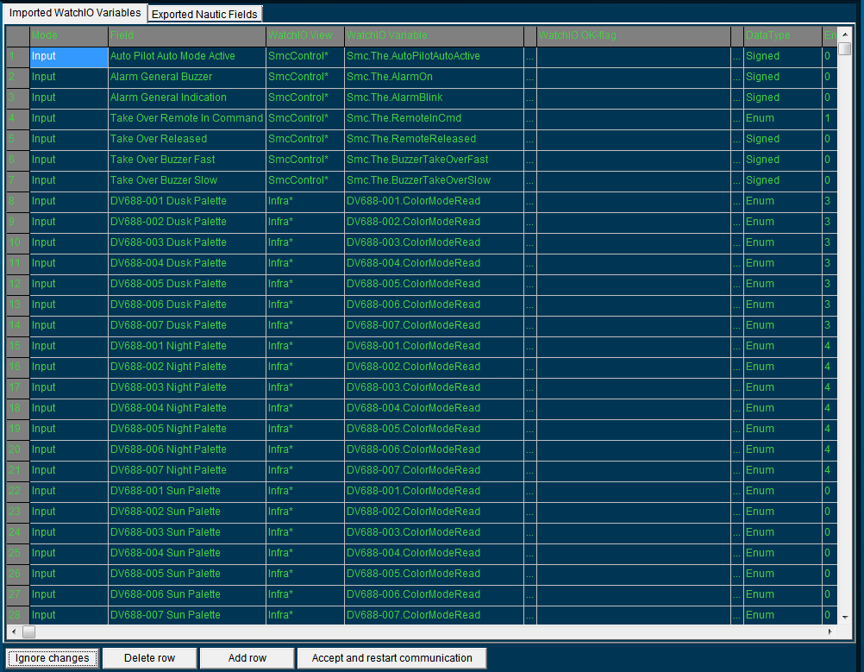

Figure 2‑62: WatchIO panel

Here you will find all the fields that are imported through the sensorlist along with all the variables that you have set in the sensorlist. By clicking on a field you can change these fields, either by a drop down menu or by changing the text. You can even add or delete complete rows. The fields that are published by NavVision are on the tab “Exported nautic fields” (see Figure 2‑63).

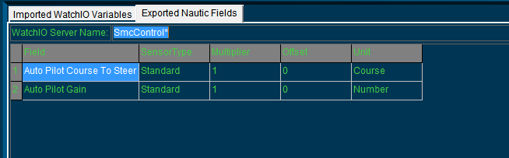

Figure 2‑63: Exported nautic fields

|  |  |
| --- | --- |
| **Detail** | **Description** |
| Ignore changes | Ignore all the changes that you have made |
| Delete row | Delete the row that you highlighted |
| Add row | Add a row at the bottom |
| Accept and restart communication | Accept changes and restart communication |

Table 2‑5: WatchIO

### Communication problems

If you have imported the sensorlist and still do not see fields under Tools>Configuration>WatchIO, than there is probably something wrong in the ini-file. Look in the NavVision folder under config>local for the file “watchIO.uc.ini”. doubleclick to open it. You will see something like the following”

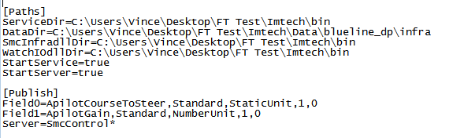

Figure 2‑64: watchIO.uc.ini

Under “Paths” check that these paths are pointing at the right location.